**TASK 2 = TO LIST ALL EVENTS**

SELECT * FROM Event;

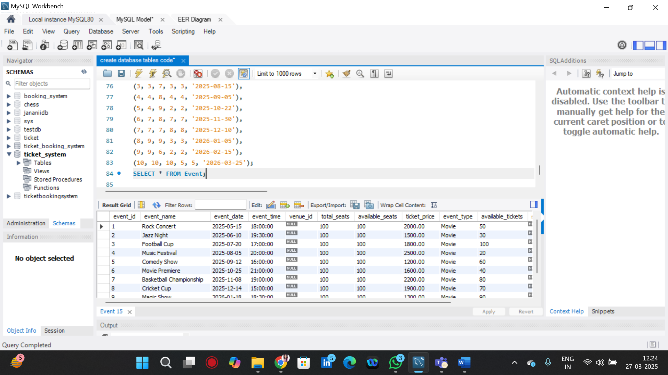

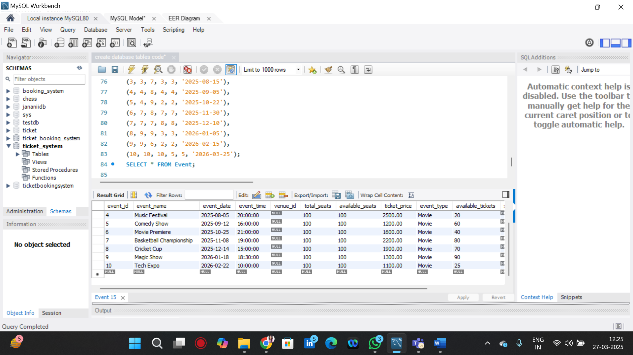

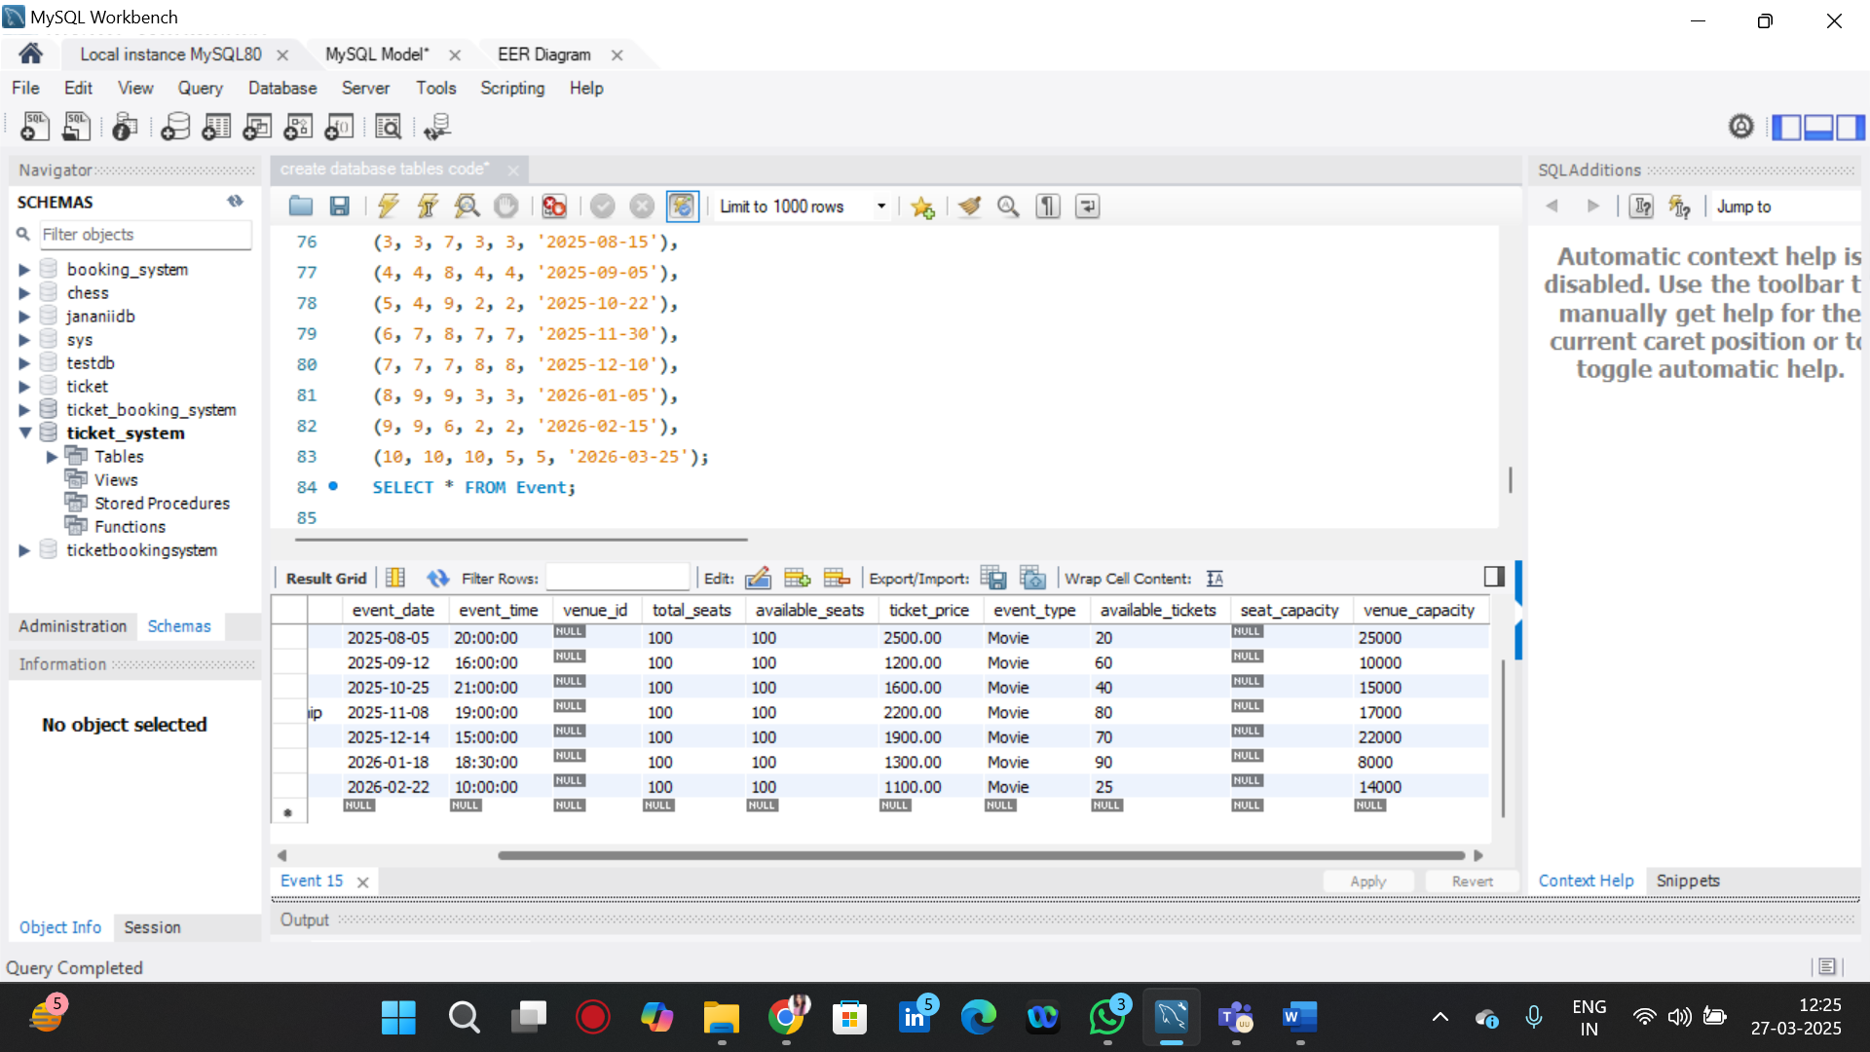

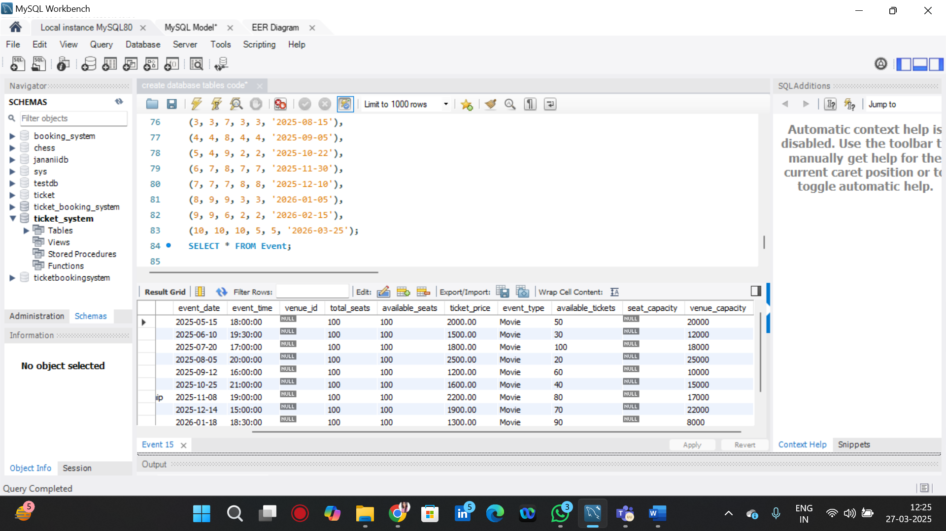

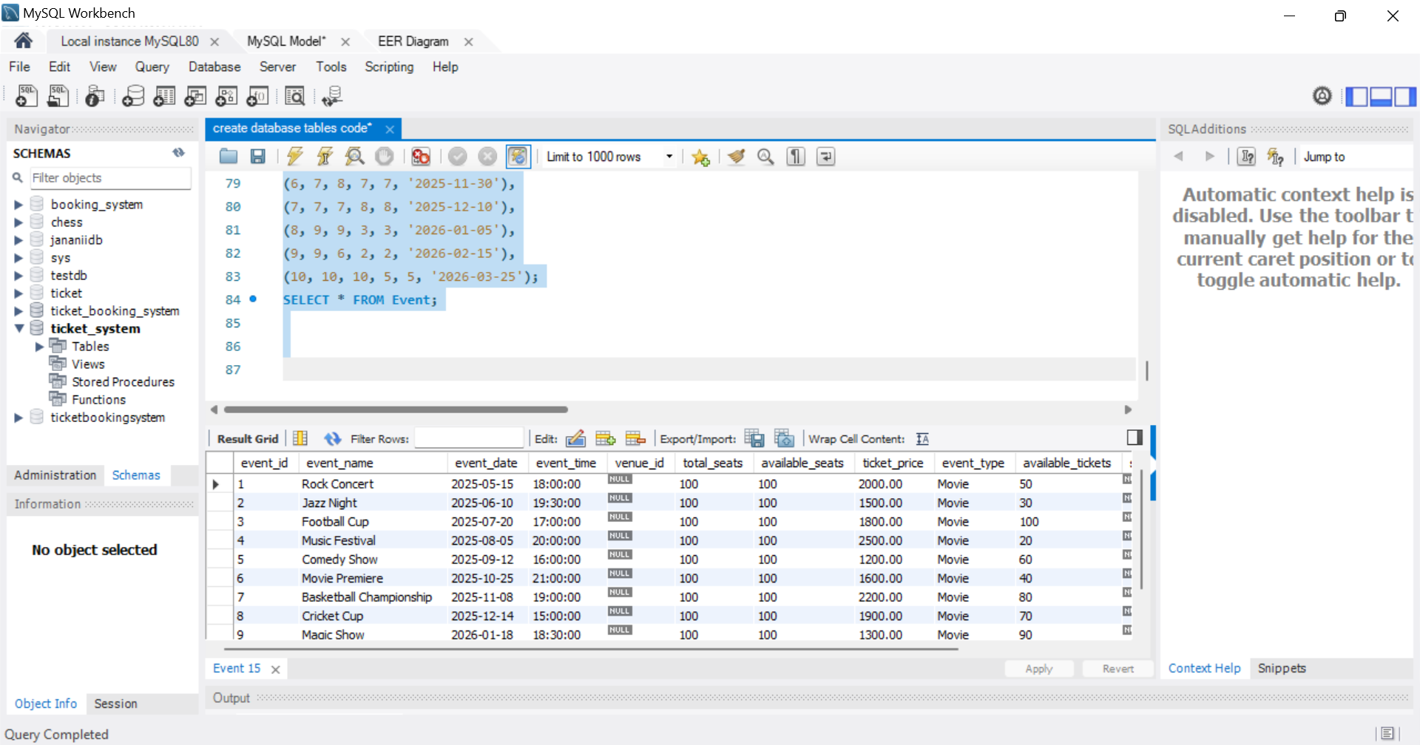

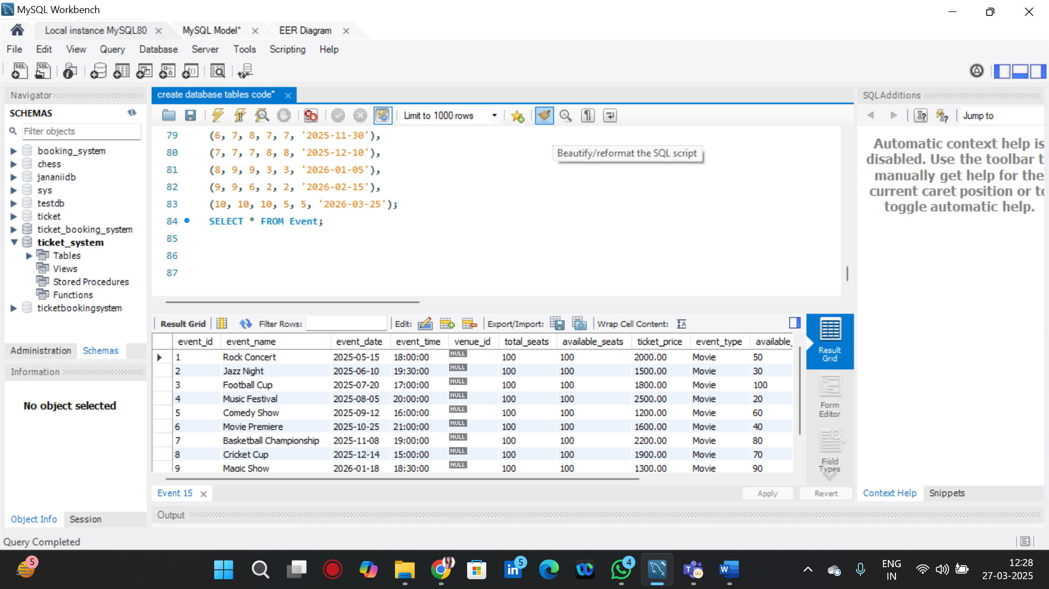

**TASK 2= TO SELECT EVENTS WITH AVAILABLE TICKETS**

SELECT * FROM Event WHERE available_tickets > 0;

SELECT * FROM Booking WHERE booking_id = 1;

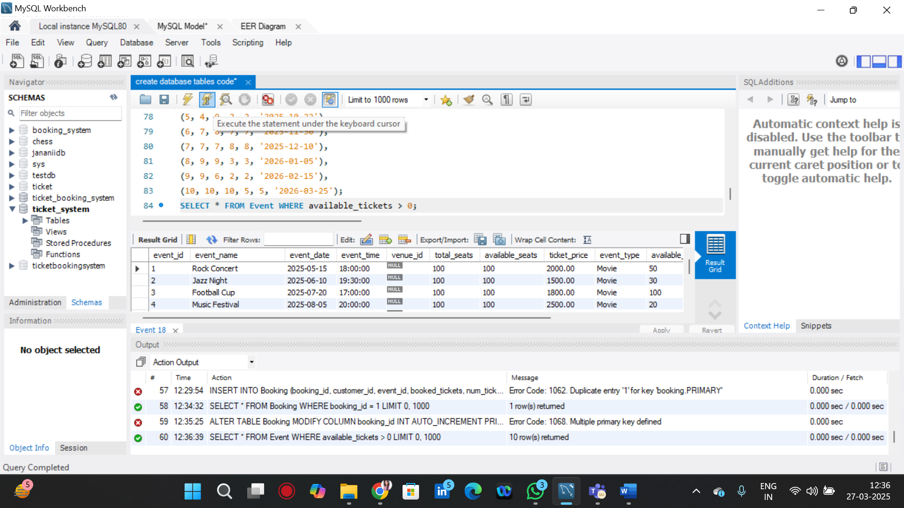

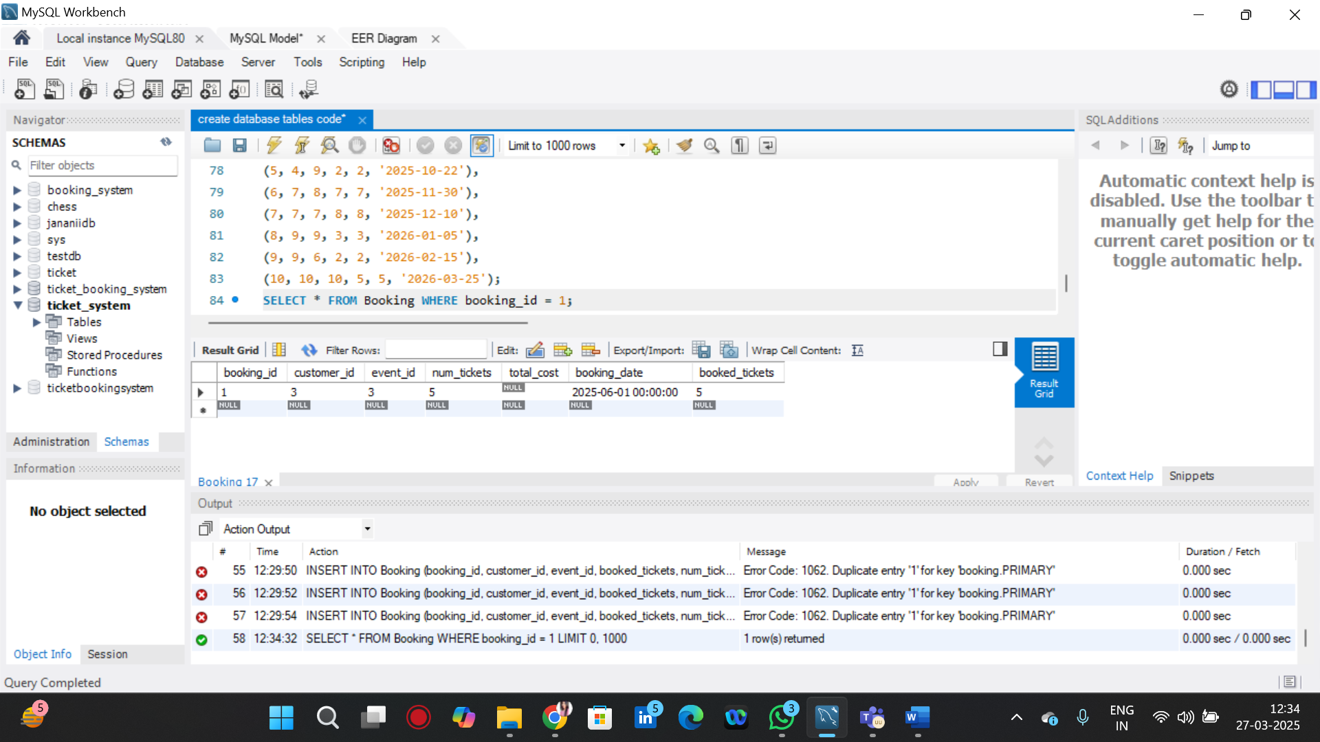

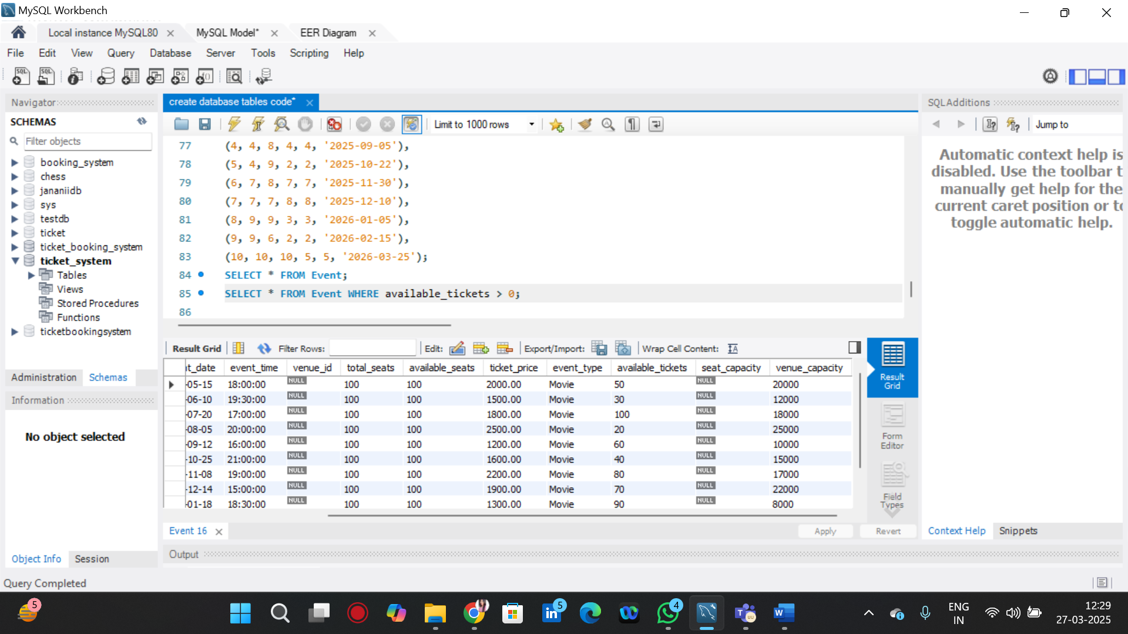

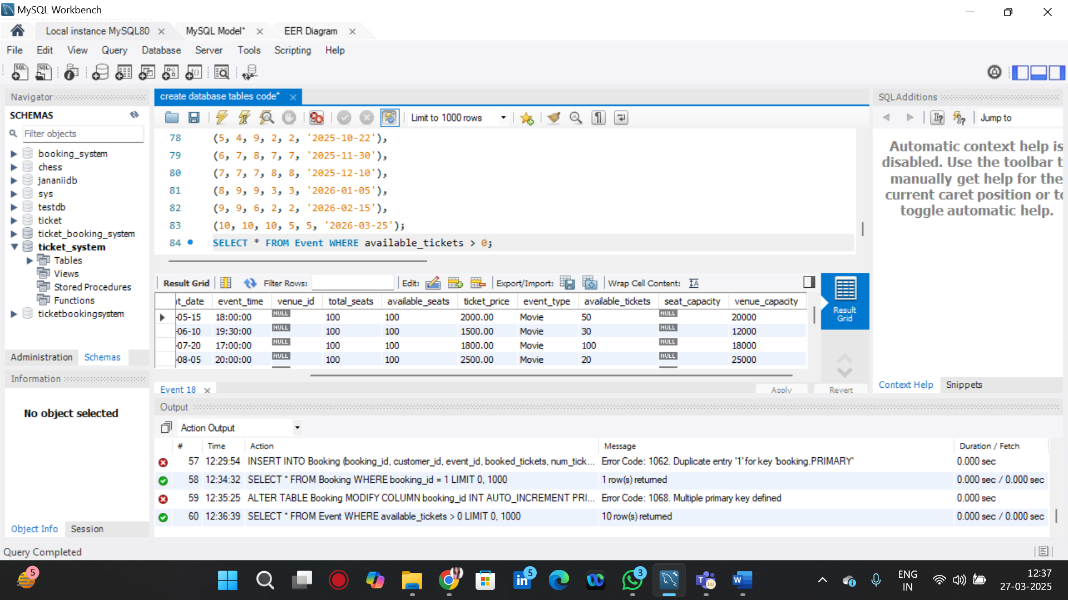

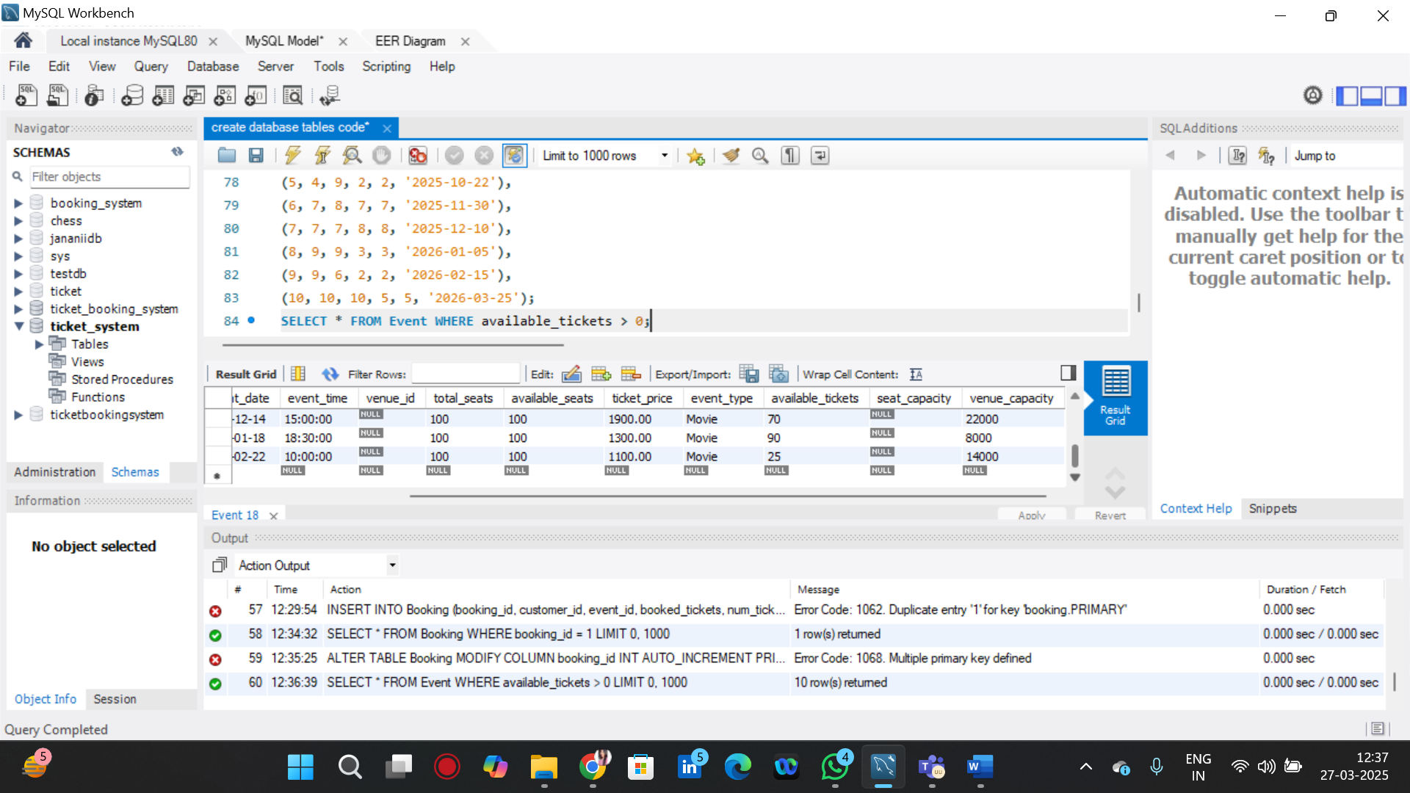

**TASK 2= TO SELECT EVENTS NAME PARTIAL MATCH WITH CUP**

SELECT * FROM Event WHERE event_name LIKE '%cup%'

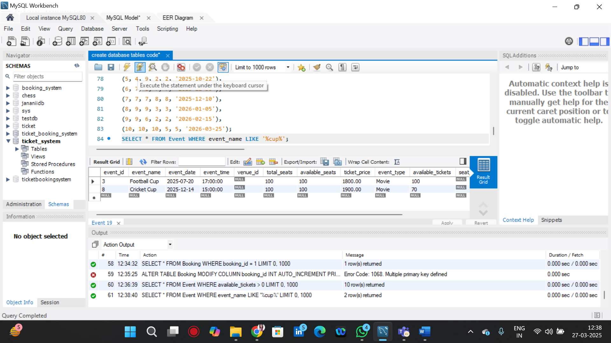

**TASK 2= TO SELECT EVENTS WITH TICKET PRICE RANGE IS BETWEEN 1000 TO 2500**

SELECT * FROM Event WHERE ticket_price BETWEEN 1000 AND 2500;

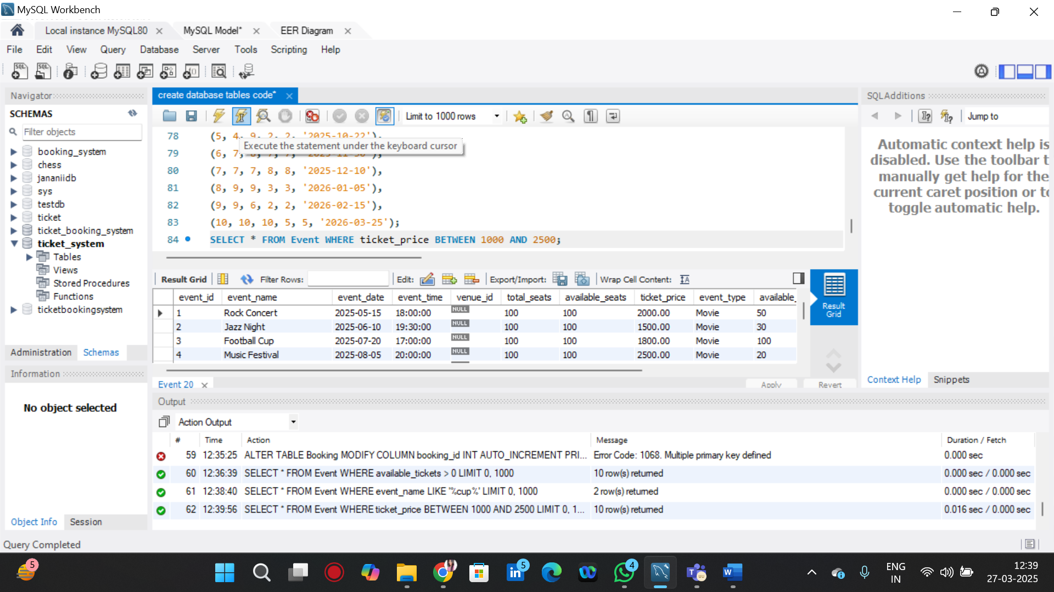

**TASK 2 = TO RETRIEVE EVENTS WITH DATES FALLING WITHIN A SPECIFIC RANGE**

SELECT * FROM Event WHERE event_date BETWEEN '2025-06-01' AND '2025-12-31';

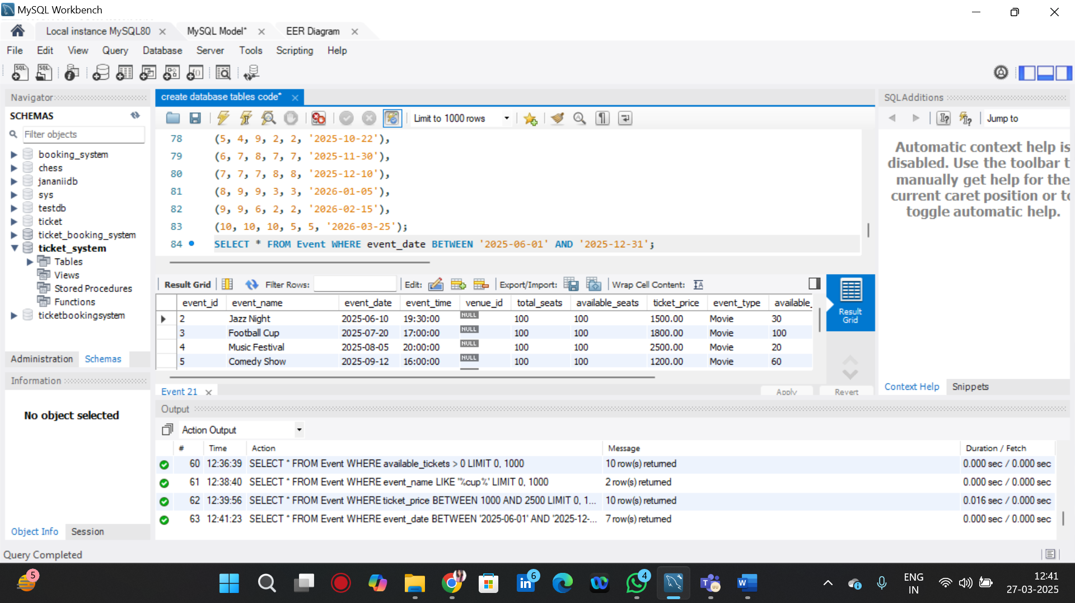

**TASK 2= TO RETRIEVE EVENTS WITH AVAILABLE TICKETS THAT ALSO HAVE CONCERT IN THEIR NAME**

SELECT * FROM Event WHERE available_tickets > 0 AND event_name LIKE '%Concert%';

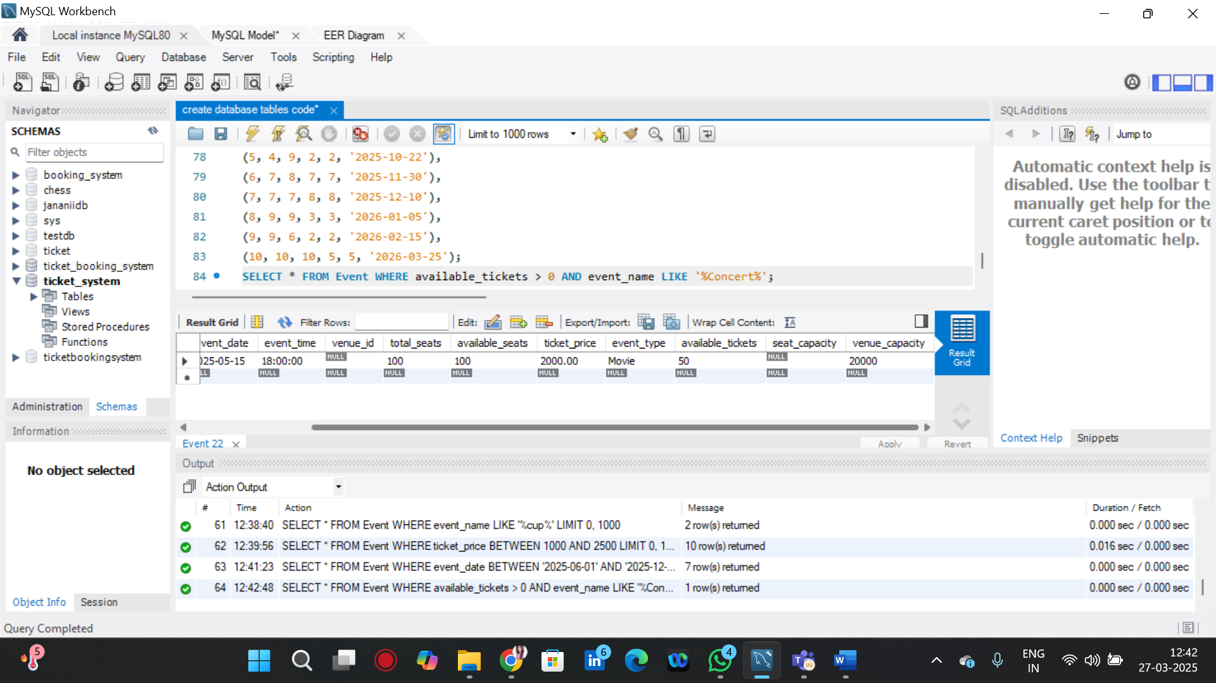

**TASK 2 = TO RETRIEVE USERS IN BATCHES OF 5 STARTING FROM THE 6TH USER.**

SELECT * FROM Customer LIMIT 5 OFFSET 5;

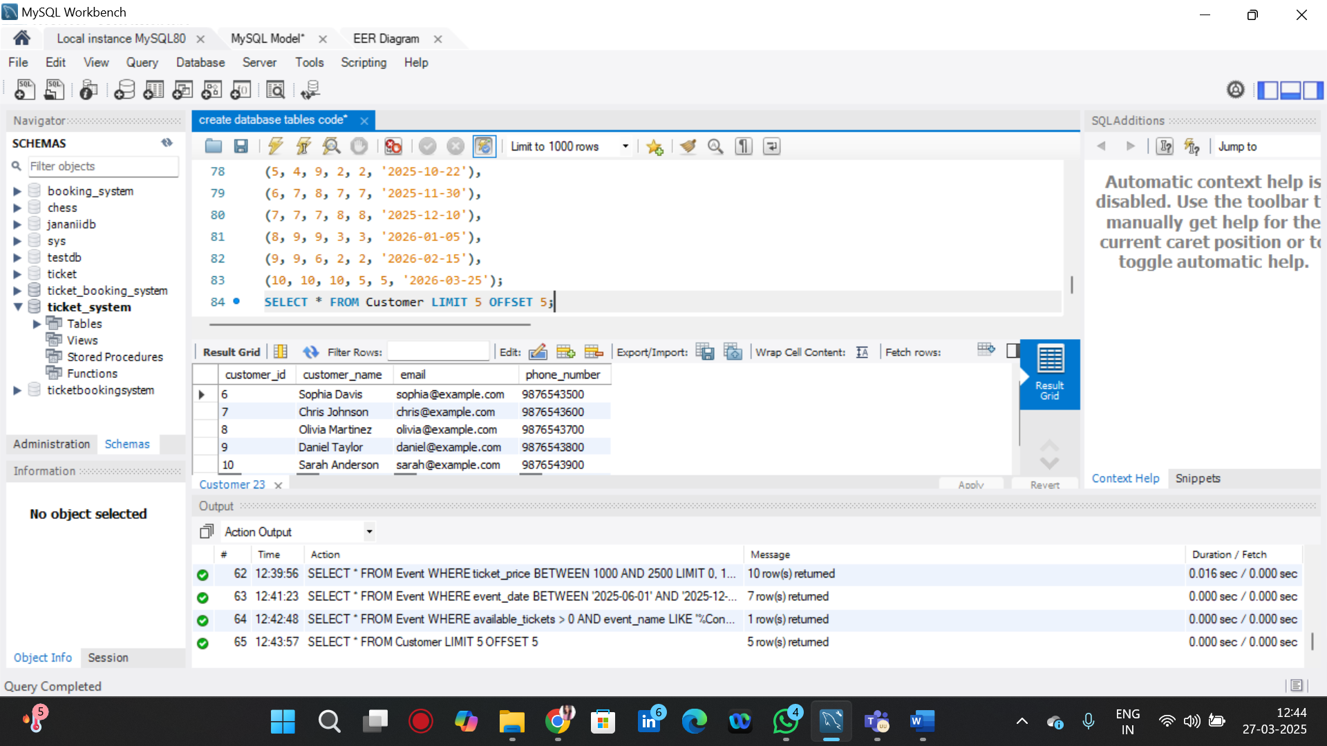

**TASK 2= BOOKING DETAILS CONTAINS BOOKED NO OF TICKET MORE THAN 4**

SELECT * FROM Booking WHERE booked_tickets > 4;

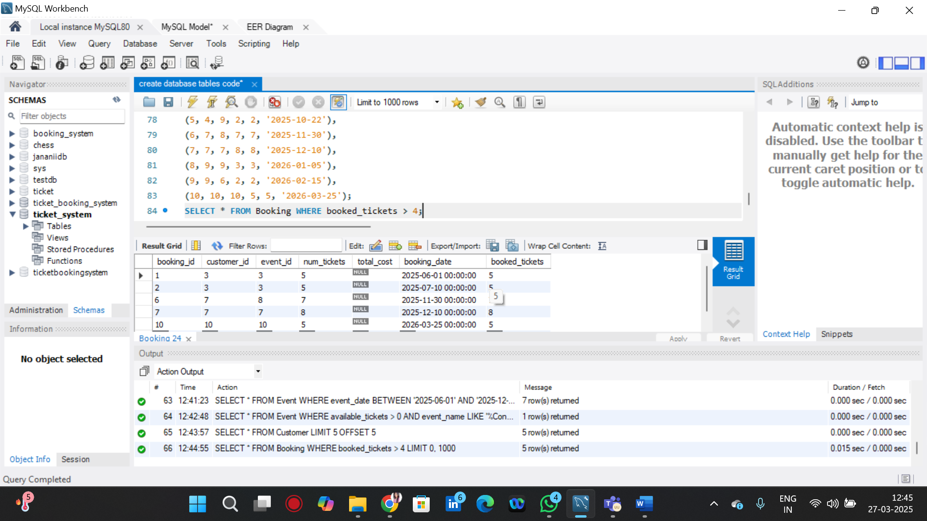

**TASK 2 = TO RETRIEVE CUSTOMER INFORMATION WHOSE PHONE NUMBER END WITH 000**

SELECT * FROM Customer WHERE phone_number LIKE '%000';

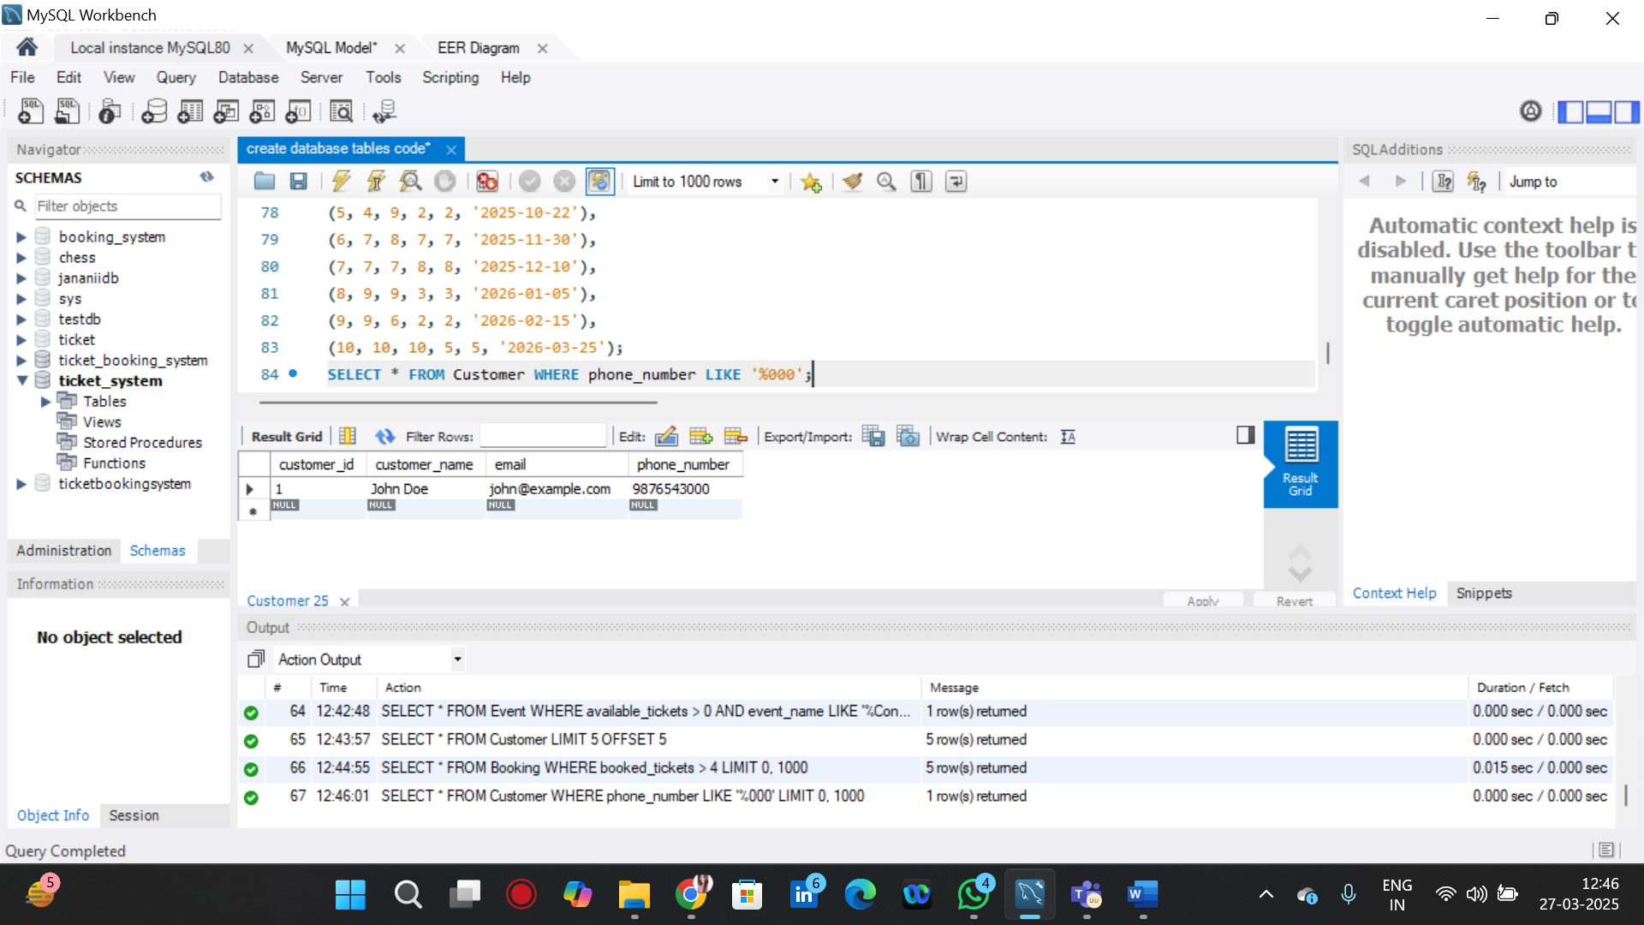

**TASK 2= TO RETRIEVE THE EVENTS IN ORDER WHOSE SEAT CAPACITY MORE THAN 15000.**

SELECT * FROM Event WHERE seat_capacity > 15000 ORDER BY seat_capacity DESC;

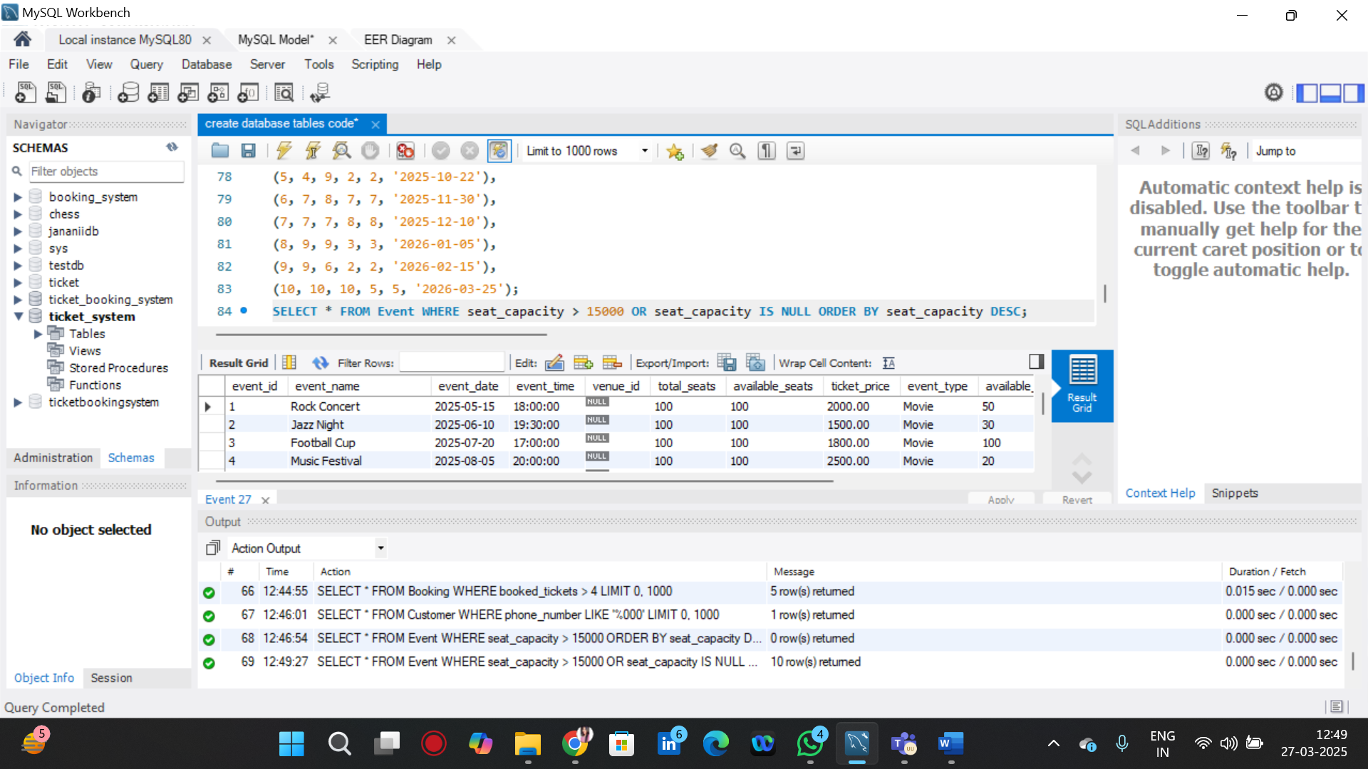

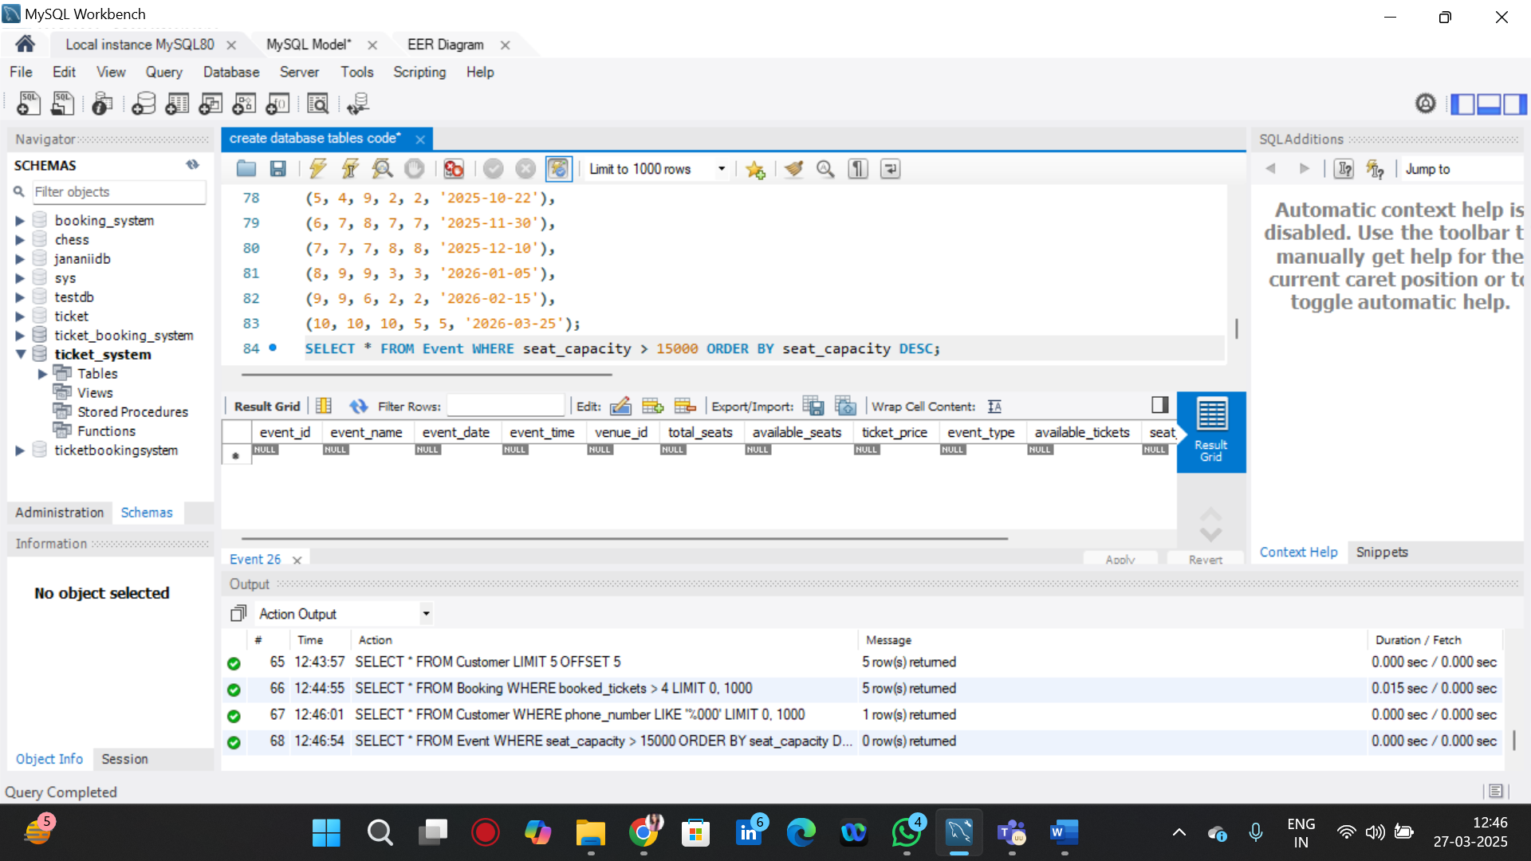

**TASK 2= TO SELECT EVENTS NAME NOT START WITH ‘X’,’Y’,’Z’**

SELECT * FROM Event WHERE event_name NOT LIKE 'X%'

AND event_name NOT LIKE 'Y%'

AND event_name NOT LIKE 'Z%';

